Assignment-2

Q1 : #taking first name from user

#taking last name from user

#concatenating two strings using + symbol

#printing full name

Q2 : #defining string alternative function

#using slicing retrieving alternate characters in the string and assigning to final string

#returning and printing final string

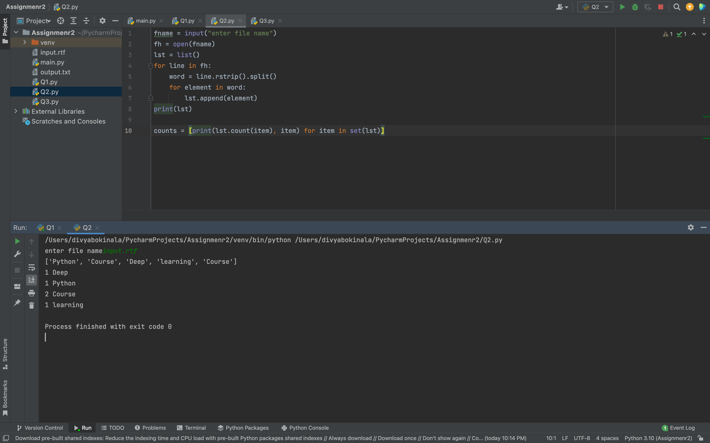

Q3 :

Video link:

<https://drive.google.com/file/d/14U9uj_ne7OkmefgjFya4fee5h8UJLPX6/view?usp=sharing>